Role of ICT in Beekeeping: A Case study of Pakistan

**Abstract**

**Keywords:**

1. **INTRODUCTION**

*=> Beekeeping in General*

All around the world Beekeeping is considered as one of the most skilled profession. Beekeeping is also known as APICULTURE. It’s the practice of managing honey bees colonies to ensure large, healthy adult honey bee population to concise with major nectar flows, and also to provide pollination services for local food crops. Nowadays some beekeepers have other objectives too for their honeybees colonies such as raising honey bees live stock for sale to other beekeepers also producing other honey bees substances, including bee pollen, propolis, and royal jelly. Beekeeping play a vital role in ecological environment by contributing to all those wild plant whose pollination is totally dependent on stabilization of bee population. All those wild flowers and natural grasses you see as you drive down a country lane exist because pollinator make it happen and these pollinators’ organization and stabilization is in the hand of beekeeper. Currently only 7 species of honeybee are recognized the best known honey bee species APIS MELLIFERA *L.* (western honey bee) which has domesticated for honey production and crop pollination. Honey bees present only a small fraction of roughly 20,000 known species of bees. But only members of the genial APIS are true honey bees in all around the world till date.

*=> Beekeeping in Pakistan, its productivity and issues in beekeeping*

In Pakistan Beekeeping is an ideal activity which provides supplementary income to a large number of rural, hilly and tribal production and also for horticulturists, agriculturists, hobbyist etc. because of the rich flora available in abundance in our country Any beginner who wants to start beekeeping in Pakistan should know some of the aspects of beehives, tools, locations where honey bees can be kept with its attempt to known honey bee and its start with one should know and learn more about honey bee and its requirement in order to make honey bee work for beekeeper. Most valuable return of the industry is the honey, wax and pollination service rendered by bees which increase yield of many of the agricultural and horticultural crops. Currently Pakistan have around 16000 beekeepers with 0.5 million honeybee colonies (according to *parc.gov.pk*). Beekeeping does not compete with other enterprises for resources as the bees use nectar and pollen grains of plants. Therefore, this enterprise can be taken up both at the household and commercial levels to generate substantially more profits.

In Pakistan Northern Punjab and KPK province are very suitable for beekeeping Because of their ecological environment but also at the same time beekeepers in these areas facing severe stress and issues because of continuous non honey production season. The major factors for creating this stress of beekeepers are raining most of times, low temperature and humidity, wrong estimation regarding hives, delayed flowering and reduced foraging activities of bees. Also last year during October, the beekeepers were able to harvest only 20% of the berry honey, due to sudden rain and wind storms during the middle of the honey flow period, which even took away the bee colonies. As a result flowers containing nectar were dropped and the bees were unable to store honey. Another critical issue in Pakistan is that beekeepers do not get any training or certification regarding the effective beekeeping and its maintenance. This lack of knowledge can lead to low productivity and most important the low quality of the honey produced. Moreover, most of the beekeepers are unaware of the health issues of the honey bee and how latest sensing, automation, and analytics technologies can assist them in more effective beekeeping. In Pakistan due to all the above-discussed issues, honey production and quality are low and are not meeting the international standards to export honey. Like developed countries, we need to introduce technology to improve this industry and to improve the quality and quantity of the honey that can uplift the country’s economy.

*=> Proposed solutions, but in our case it will be recommendation*

As a fact Bees are very important for terrestrial ecosystems and, above all, for the subsistence of many crops, due to their ability to pollinate flowers. Currently, the honey bee populations are decreasing because of colony collapse disorder and climate changes. The reasons for colony collapse disorder are not fully known till date, and as a result, beekeepers faced this issue from several years not only this they are also challenging the wrong estimation regarding health of bees and nectar dearth(Scarcity of nectar). So to defeat all these issues we come up with our smart solution. Which is especially designed for monitoring beehives remotely in real time using IOT(Internet of things) and other technology tools. Our recommended solution is based on a custom IOT module which is composed of some environmental sensors(eg: temperature/humidity ,weight, acoustic sensors). That will helps to collect data from surrounding environmental parameters of beehives and monitor the current condition of beehives and then finally reflect that data to end user using wireless technology as a medium. We think that if our recommended solution once implemented in Pakistan then it will bring a huge change in beekeeping field as well as in country economy.

Organization of paper:

1. **BACKGROUND STUDY**

In past several years different techniques and methodologies have been used for monitoring beehives using technology. We have approached this section first by discussing the work done in literature by targeting research papers and second part is about the commercially available products for beehive monitoring.

**2.1 Literature review**

In [1] programmer Mat Kelsey created a IOT based bee counter to see just how many of his winged honey makers are hanging out in his hives. His system, which uses a Raspberry Pi, Standard Pie camera ,Image processing and a machine learning algorithm that recognizes the number of individual bees entering a hive, is used to see bee trends over time and see just how the bees are faring. So far MAT faced the only problem while integrating the algorithms is that standard raspberry pie camera only able to run at one frame pre second due to computational requirements of identifying the bees. But later on he got some ideas to improve the situation. This research based project of MAT KELCY seems to be a good and effective solution but just for some beekeepers who have external beehives while it’s failed for all those beekeepers who have external beehive in beehives box also the cost of an individual product based on this research After its release will quite expensive Because of the camera Lens that used for capturing images of beehives 24/7 that makes it not feasible for beekeepers as most of the beekeeper are financially weak in this part of the world.

In [2] a Vision-Based Bee Counting Algorithm for Electronic Monitoring of Beehives was presented by *Sai Kiran Reka* in his final year project for MS computer science. They created a new algorithm that count bee numbers in images of farm beehive entrances. The algorithm computes approximate bee counts by adjusting the brightness of the image, cropping a white or green area in the image, removing the background and noise from the cropped area, finding the total number of bee pixels, and dividing that number by the average number of pixels in a single bee. On 1005 images with green landing pads, the algorithm achieved an accuracy of 80 percent when compared to the human bee counting. On 776 images with white landing pads, the algorithm achieved an accuracy of 85% compared to the human bee counting.

In [3] Mark Leppard discovered a new way of monitory bee hives which is actually done by observing the acoustic signals of bees and then using these acoustic property of bees as a seed for finding all other possible environmental variables of beehive. He used a passive microphone sensor as input to avoid electromagnetic field at some extent and then pass the input from some difficult processes including noise filtering, data extraction, data mapping, data collection and many more to take out the desired information from input and to designed such a system that will automatically acquire, process and analyze audio data from remote honeybee hives, in order to help alleviate the time and energy required for manual monitoring. In [14] *Rustia* and  *Dan Jeric Arcega* proposed an IoT(Internet-of-Things)-based monitoring system with environmental condition monitoring using wireless sensor networks as support for an in and out honeybee activity tracking system using real-time image processing. Their proposed system provides real-time updates, data management, statistical analysis, and alerts through a website and Android APP in order to determine the effects of the environmental condition, pesticide dosage, and age differences to the in and out activity of honeybees. But their solution failed to monitored multiple hives accordingly and secondly its setup also not cost effective and feasible for local beekeepers. In [17] [*Armands Kviesis*](https://www.researchgate.net/profile/Armands_Kviesis) *&* [*Aleksejs Zacepins*](https://www.researchgate.net/profile/Aleksejs_Zacepins)proposed different system architecture for monitoring the real-time temperature of beehive using technology  they focused on different automatic monitoring system architectures or monitoring approaches for real-time beehive temperature monitoring. After doing experiments with all of their approaches they distinguished the advantages & disadvantages of their approaches in which one drawback is common that is using only one temperature sensor and temperature parameter for monitoring the overall beehive is not enough which make their approaches a little unproductive and infeasible for beekeepers.

**2.2 Commercial products**

Some of the products based on beehive monitoring paradigm that are available commercially are discussed here. In [4][5]  *KELTON TEMBY* used *Mat Kelcy*  approach to develop such an electronic device that will detect the Health of hive using image processing and Machine learning algorithms he implement the same thing and its results are fruitful. *Kelton Temby* named this product as EYESONHIVES using which one can easily observe the health of beehive and other parameters by using the device as input to the hive and there User interface software as Result for user in the form of web App. But the worse thing about this device is its only for external hives not made for internal hive secondly its first launch price was 1200$ and nowadays its price is 249- 320$ which is not cost effective and feasible for a poor beekeepers. In [6][7] *ARNIA company* who claimed that we have modern solution for all of your modern problems recently created a Beehive monitoring system based on a separate hardware that should be installed inside a hive and then for the device observation user have to login to their live website.

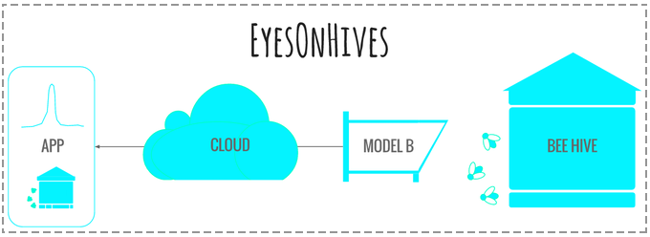

*Figure: Integrated EYESONHIVES model B, captured data is move to cloud for processing and then shared the information to user Interface*

Similarly In [8][9][10] alternatives of *Arnia* was built by different companies and launched this products commercially but because of its high expenses these solutions are not feasible for an ordinary beekeeper as most of beekeepers are not financially strong. In [11], different gas sensors are integrated to monitor the in-hive condition of each individual colony. The impact of temperature, chemical pollutants, dust and humidity on the bee health and honey production were analyzed. Another approach with the name BuzzBox [12] focused on the audio data generated by the bees to determine the bee condition. A mobile application is developed for getting alerts of the beehives. BuzzBox seems to be a good solution but the cost of an individual box is quite expensive that makes it not feasible for beekeepers as most of the beekeeper are financially weak in this part of the world.



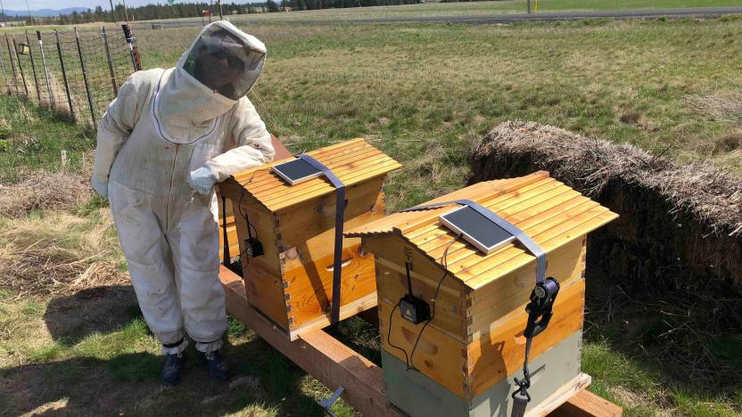

*Figure: BuzzBox a smart IOT sensor that will monitor health of bees. Making beehives healthier and smart.*

In [13], the traditional frame named as MiteNot was replaced with commercial frame having Internet connectivity. Each frame has sensors and a heating element. The main functionality of the frame is to sterilize the eggs of mites to stop spreading of pest in the hive. A real-time image processing based honeybee in and out activity with the help of environmental sensors was proposed to analyze the activities in beehives [14]. However, the number of bees in each beehive is in thousands that makes it difficult to analyze the images in real-time as the bee in-out traffic is very frequent.

1. **ICT for Beekeeping in Pakistan**

In Pakistan **Beekeeping** is a profitable business. About 7,000 **beekeepers** are now rearing exotic species, Apis mellifera in the modern beehives. There are about 300,000 colonies producing 7,500 metric ton honey annually (according to <parc.gov.pk>). In addition 80% of the people that are involved in beekeeping are Afghani and merely 20% are Pakistanis, which is a big concern itself. Pakistan being an agricultural rich economy needs to leverage state of the art technology and tools to improve the honey production and overall beekeeping process. Most of the beekeepers do not have a basic knowledge of the domain and are associated with the industry for making ends meet. Lack of modern technology usage and updated marketing techniques is sufficiently lacking. All these directly affect both sides like production and quality. Due to high food quality standards, Pakistan is not able to export honey to major global markets such as European markets which is really a big concern.

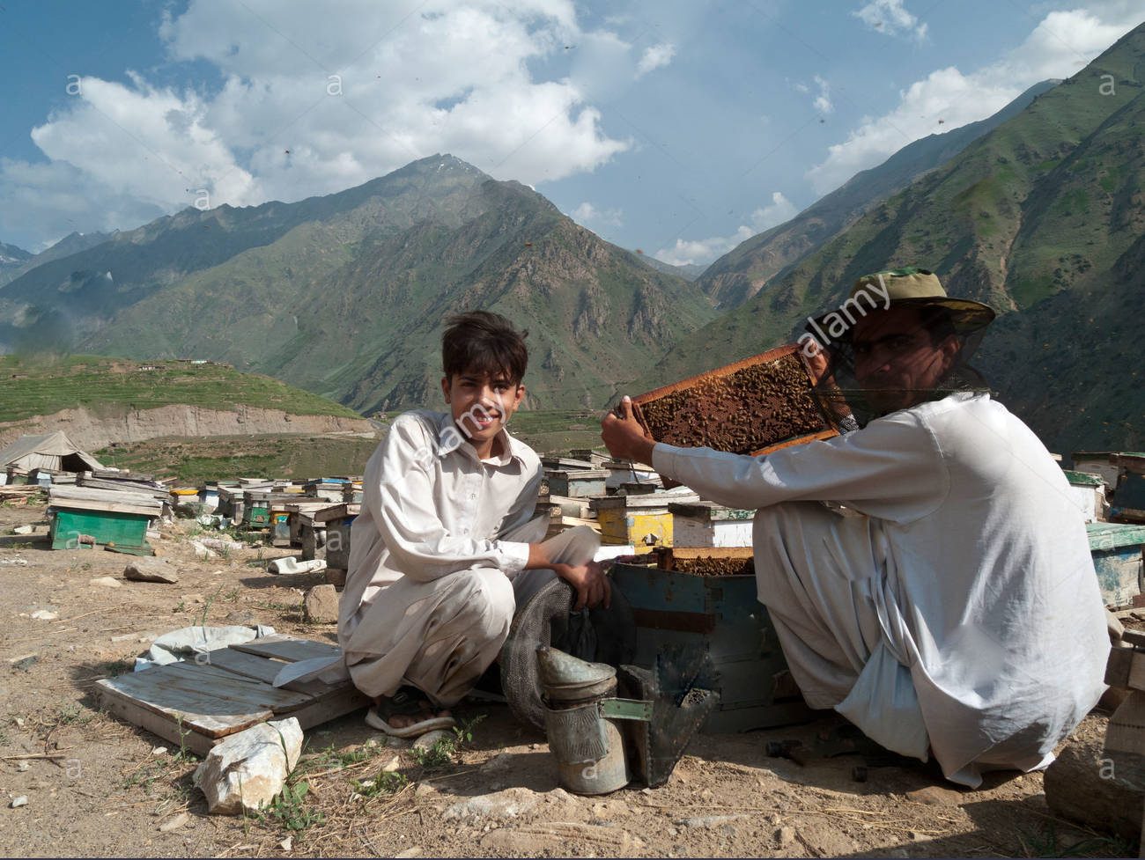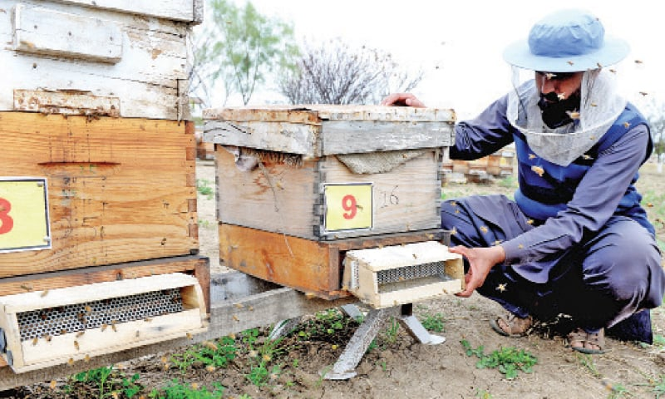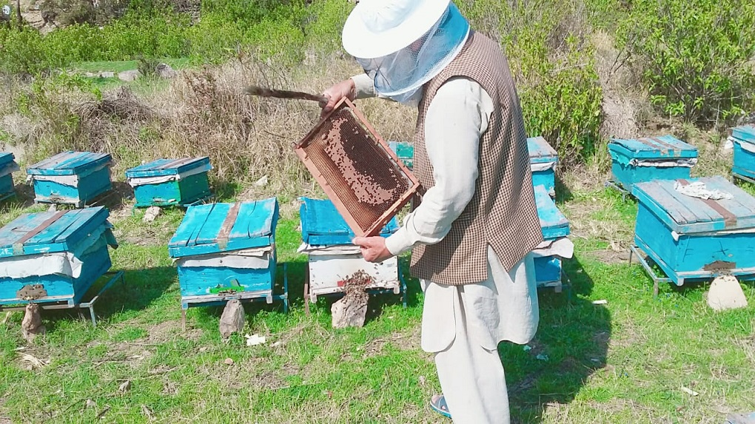

*Figure: Traditional way of producing honey in northern areas of Pakistan [15][16] .*

To ensure quality honey and improved production, bee health needs to be monitored. In traditional methods, bee health is often sidelined or not tackled on time that can lead towards low productivity and in the worst case the whole colony can be affected. Most of the beekeepers do not have sufficient knowledge of the domain that leads towards low productivity and most importantly they are unaware of the bee health. Till date in Pakistan there is no such technique for monitoring beehives using technology. As Pakistan is an agricultural country where it accounts for 25% of the gross domestic product (GDP) that plays an integral part in the country’s economy. In the coming years, agriculture will continue to be the most important factor in the country’s economy. Beekeeping is an attractive and profitable business in Pakistan, however the honey production in the country is lowering year by year because of lack of knowledge towards this sector. Due to the use of honey in a variety of different products, In Pakistan its demand is increasing day by day.

1. **RECOMMENDATIONS**

*Fourth section Recommendations*

Bees are very important for terrestrial ecosystems and, above all, for the subsistence of many crops, due to their ability to pollinate flowers. Currently, the honey bee populations are decreasing due to colony collapse disorder and Climate changes. The reasons for colony collapse disorder are not fully known, and as a result, it is essential to obtain all possible information on the environmental conditions surrounding the beehives. On the other hand, it is important to carry out such information gathering as non-intrusively as possible to avoid modifying the bees’ work conditions and to obtain more reliable data. To overcome all these problems of beekeeping & stress of beekeepers in Pakistan we recommend our updated IOT based online beehive monitoring system. We recommend our IOT based digital device that meets all of the above requirements and convert a simple beehive to smart beehive. Our online remote beehive monitoring system is based on Modern Technology tools including IOT, Machine learning algorithms, Data analyzing and Network management. Which monitor some of the most important environmental parameters of beehive 24/7 such as temperature & humidity of hive, weight of hive, gasses produced and the most interesting one the current health of bees inside hive and availability of bees that either they are present in hive or not, either they have some colony escape disorder or not by demonstrating the acoustic property of Bees. Once Beekeepers have exact knowledge of all these parameters of beehive environment then they can easily found the current health of bees and the correct estimate of honey production. So in short our recommended solution is aimed to provide such a digital device to local beekeepers to monitor the hive live condition and provide them the opportunity to monitor their colonies in real-time at a low cost. With the help of the graphics or a decent user interface, the beekeepers could know and observe what is going on inside the hive 24/7 .Beekeeper will be informed in case of crossing or lowering the threshold so that precautionary measures can be taken on time. Data analytics is very important for decision making, better planning and research purposes, however here in Pakistan there is no such dataset available that can be used for such activities. By developing the proposed system we will not only generate a significant dataset that can be used for statistical analysis, validation of proposed improvements and tested for better results to further investigate the system but also be able to recommend changes in beekeeping process in order to improve the yield and overall quality of honey. Keeping in view all of the above issues, we are proposing a comprehensive architecture for integrated IoT enabled beehives that can cope with pertaining issues of low yield and degraded quality through effective use of information and communication technologies. The System Architecture of our device is composed of digital sensors, microprocessor, wireless network, machine learning algorithms, power supply and user interface All sensors including in this device are temperature and humidity sensors, digital weight sensor and piezobuzzer or passive microphone for taking Acoustic signal as input these all modules are directly connected to a Raspberry pie which will then manipulate the data and send it to the clients using wireless module of Raspberry pie. The aimed of including weight sensor as weight of the hives has allowed us to understand the evolution of the bee colonies during blooms, in particular, during a commercial sunflower bloom, as well as its practical application in usual management by beekeepers. As an example, it allows us to register the evolution of the production of honey in the hives or the end of the bloom and estimate the production of honey or indicate the most appropriate moment for the collection of the honey in advance, preventing unnecessary trips to the apiary by the beekeeper.

So once data sent from hive successfully then it’s time for processing data and showing it to the user end in the form of information which is done by Machine learning algorithms and also with some conventional bees counting algorithms using acoustic signals. When all manipulation on data is done then it will be send to user using in the form of Android ,Desktop or web application so that beekeepers can monitor their hive digitally with a cost effective and feasible prices and that’s what special about our recommended solution it’s give you a huge opportunity for monitoring your beehives remotely in a very decent prices no need of wasting a large amount Rupees on conventional methods for monitoring beehives and finally this whole scenario will make its integration in successful meanings a cost effective and feasible way of monitoring beehives remotely 24/7.

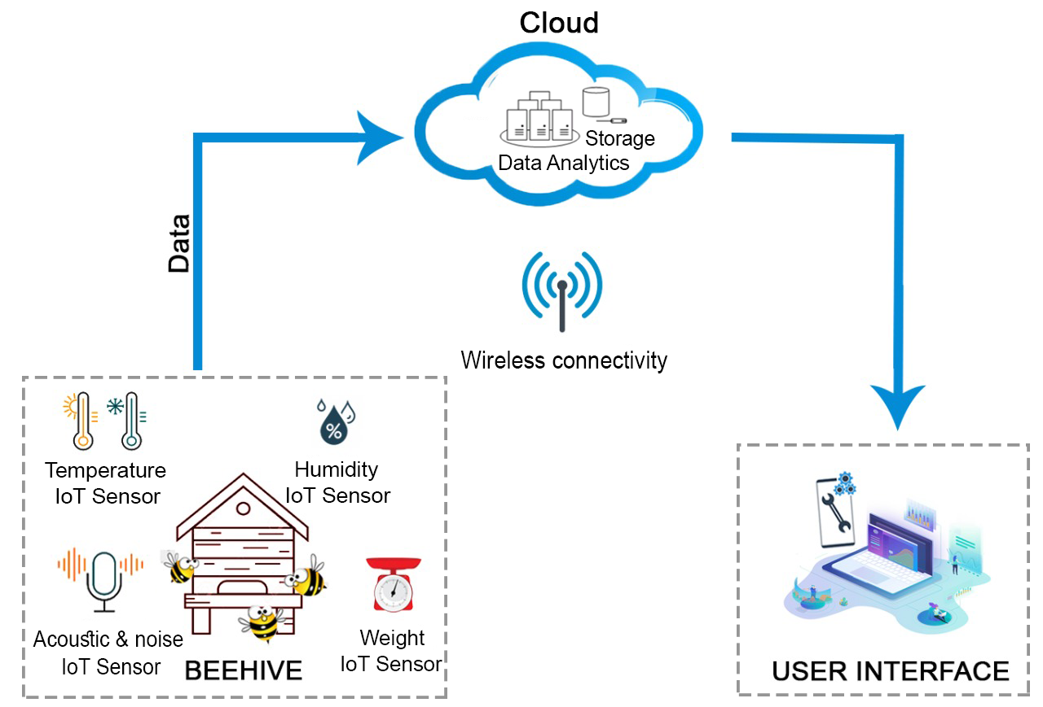

Figure: System Architecture of our recommended cost effective and feasible IOT module based solution.

1. **CONCLUSION**

In this paper, we recommended a system prototype for remote monitoring of beehives. This is rather a non-intrusive approach of dealing with pest infestation problem in the honeybee industry in Pakistan. The developed prototype is capable of capturing and analyzing of acoustic samples collected from beehives. We showed how technology proved helpful for honeybee industry. So if this prototype will integrated successfully then consequently, it will improve the overall state of beekeeping, particularly in the following ways.

1. Beekeepers will be able to remotely and continuously monitor all the beehives.
2. This will allow them to detect diseases, anomalous behavior of bees and attend to any emergencies on time, thereby reducing losses.
3. Data collected from the beehives over one period of honey production will reveal useful insights through the use of data analytics which will help in better planning and management in the future.
4. Continuous monitoring will make it possible to study the effects of the environment on bee health and honey quality. Moreover, understanding the behavior of bees can also be investigated through acoustic analysis.
5. Honey bees are a good source of pollination that contribute towards crop yields around 30%. Therefore, improving beekeeping means contributing to society by providing excellent and healthy food in the form of honey.
6. People prefer natural and healthy alternatives instead of using artificial sweeteners. Moreover, it is widely used in medicine.
7. Beekeeping is an environmental friendly contributing to negligible pollution unlike other production units.

In a nutshell we can say that technology assisted beekeeping monitoring system will bring a huge change in Pakistan Beekeeping field and also indirectly in Pakistan economy as well. Because of their major effective reasons and also because of its price which is cost effective and feasible for almost all type of beekeepers in Pakistan.

**References:**

[1] Mat kelcy official article about counting bees using Raspberry pie research <http://matpalm.com/blog/counting_bees/>

[2] Sai kiran Reka algorithm for Counting bees research <https://drive.google.com/open?id=17vycN8OBdIKi6C04PT7IGbPhjBp01nTA>

[3] Mark Leppard Research based on Acoustic signal of bees <https://www.researchgate.net/publication/275517604_Remote_Beehive_Monitoring_using_Acoustic_Signals>.

[4] A smart ICT product for monitoring Beehive named **EyesOnHives** by Tektronix Inc.**,** 2015 <https://www.keltronixinc.com/>

[5] EyesOnHives official websites for buying this commercial product <https://www.eyesonhives.com/>

[6] World most famous beehives monitoring system which provide online connectivity to your beehive from all around the world, 2017. [https://www.arnia.co.uk/ products /](https://www.arnia.co.uk/how-it-works/)

[7] Theory Behind ARNIA Beehive monitoring system. [https://www.arnia.co.uk/ how-it-works /](https://www.arnia.co.uk/products/)

[8] All in one Bee Farm Monitoring system. <https://beehivemonitoring.com/en/>

[9] The Bee ware hive monitoring system. <https://solutionbee.com/>

[10 IOT and Android technology help solve the problem of online Beehive monitoring system. <https://io-bee.eu/>

[11] Reading Beehives: Smart Sensor Technology Monitors Bee Health and Global Pollination, 2015 <http://www.libelium.com/temperaturehumidity-and-gases-monitoring-in-beehives/>

[12] Theory Behind BuzzBox Audio Analysis, 2017. <https://docs.opensourcebeehives.com/docs/theory-behind-audio-analysis>

[13] Gemalto's IoT Technology helps Solve HoneyBee Crisis, 2017. <http://www.gemalto.com>

[14] Rustia, Dan Jeric Arcega, Ngo Thi Nha, and Ta-Te Lin. "An IoT-based information system for honeybee in and out activity with beehive environmental condition monitoring."

<https://www.researchgate.net/publication/320134391_An_IoT-based_information_system_for_honeybee_in_and_out_activity_with_beehive_environmental_condition_monitoring>

[15] Extracting honey the tradition way according to Dawn

<https://www.dawn.com/news/1392980>

[16] Honey production in Pakistan and effects of climate changes on Pakistani beekeepers

<https://www.thethirdpole.net/2020/04/03/climate-change-deforestation-cripple-pakistans-honey-exports/>

[17] [Armands Kviesis](https://www.researchgate.net/profile/Armands_Kviesis) & [Aleksejs Zacepins](https://www.researchgate.net/profile/Aleksejs_Zacepins) “System Architectures for Real-time bee colony Temperature Monitoring”

<https://www.researchgate.net/publication/273578781_System_Architectures_for_Real-time_Bee_Colony_Temperature_Monitoring>

************************************************************************